Matthew Carlson

Gavin Rodriguez-Thompson

We used the four original algorithms (or as close as we could get to them) using Dijkstra's pathfinding algorithm as the base. Using the same path finding algorithm, we tested out a custom algorithm where the ghosts try to flank the player on all sides. We found that results varied very little when changing the position of Pacman, most of the differences were along the lines of ghosts getting stuck in a loop of back and forth commands. We believe that, that particular problem can be solved with a better graph representation, and tweaking values.

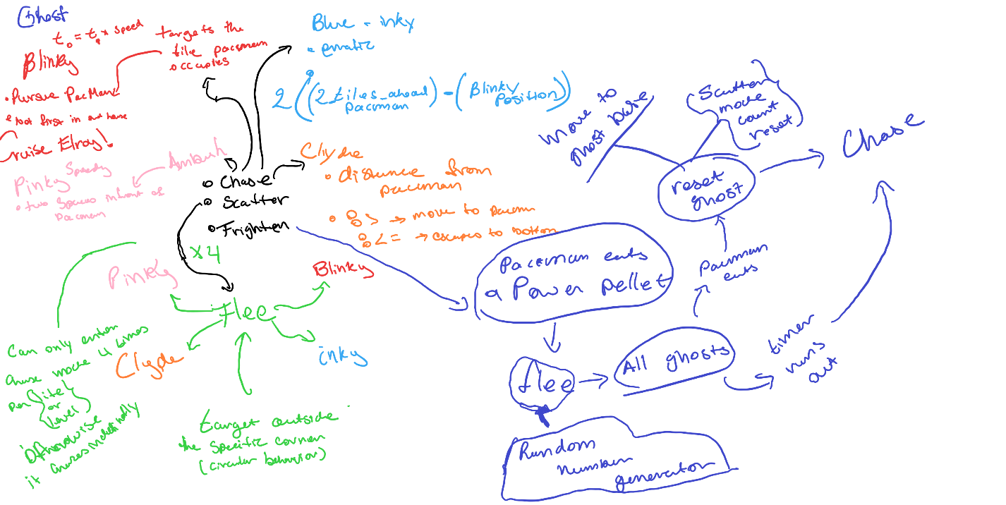

We were unable to successfully create some of the interactions (such as the proper scatter behavior) we laid out, but the basis of the ghost and Pacman interactions are implemented in this assignment.